Menaka 13/12/2023

How to visualize the content of the Data in easy understandable way in the excel and more visual representable way in Tableau

Data Visualization using Excel and Tableau

Assignment using Tableau and Excel

Data Protection Principles 1

# Data Visualization using Excel 3

1.Top 20 Ranked Countries GDP information 4

2.The chart for the whole country GDP information 5

3.Chart for the Top Ranked Countries chart and its macro buttons (Copy,Save,Delete) 6

4.All Countries GDP Information and its chart 8

# Data Visualization using Tableau 12

5.**Tableau Top 20 Ranked countries GDP chart** 12

**6.Top 20 Ranked Countries Life Expectancy at birth Info Chart in Tableau** 13

**7.Top 20 Ranked Countries smartphone users Chart** 14

8.Top 20 Ranked Countries Life Expectancy and SmartPhone Uers Chart 14

# Data Protection Principles

These are the seven principle need to be adhered while working with Data as Data analyst

* [Lawfulness, fairness and transparency](https://ico.org.uk/for-organisations/uk-gdpr-guidance-and-resources/data-protection-principles/a-guide-to-the-data-protection-principles/the-principles/lawfulness-fairness-and-transparency/)
* [Purpose limitation](https://ico.org.uk/for-organisations/uk-gdpr-guidance-and-resources/data-protection-principles/a-guide-to-the-data-protection-principles/the-principles/purpose-limitation/)
* [Data minimisation](https://ico.org.uk/for-organisations/uk-gdpr-guidance-and-resources/data-protection-principles/a-guide-to-the-data-protection-principles/the-principles/data-minimisation/)
* [Accuracy](https://ico.org.uk/for-organisations/uk-gdpr-guidance-and-resources/data-protection-principles/a-guide-to-the-data-protection-principles/the-principles/accuracy/)
* [Storage limitation](https://ico.org.uk/for-organisations/uk-gdpr-guidance-and-resources/data-protection-principles/a-guide-to-the-data-protection-principles/the-principles/storage-limitation/)
* [Integrity and confidentiality (security)](https://ico.org.uk/for-organisations/uk-gdpr-guidance-and-resources/data-protection-principles/a-guide-to-the-data-protection-principles/the-principles/integrity-and-confidentiality-security/)
* [Accountability principle](https://ico.org.uk/for-organisations/uk-gdpr-guidance-and-resources/data-protection-principles/a-guide-to-the-data-protection-principles/the-principles/accountability-principle/)

**Lawfulness**

* ☐ We have identified an appropriate lawful basis (or bases) for our processing.
* ☐ If we are processing special category data or criminal offence data, we have identified a condition for processing this type of data.
* ☐ We don’t do anything generally unlawful with personal data.

**Fairness**

* ☐ We have considered how the processing may affect the individuals concerned and can justify any adverse impact.
* ☐ We only handle people’s data in ways they would reasonably expect, or we can explain why any unexpected processing is justified.
* ☐ We do not deceive or mislead people when we collect their personal data.

**Transparency**

☐ We are open and honest, and comply with the transparency obligations of the right to be informed.

* ☐ We are open and honest, and comply with the transparency obligations of the right to be informed.

Purpose limitation

☐ We have clearly identified our purpose or purposes for processing.

☐ We have documented those purposes.

☐ We include details of our purposes in our privacy information for individuals.

☐ We regularly review our processing and, where necessary, update our documentation and our privacy information for individuals.

☐ If we plan to use personal data for a new purpose other than a legal obligation or function set out in law, we check that this is compatible with our original purpose or we get specific consent for the new purpose.

Data Minimisation

You must ensure the personal data you are processing is:

* adequate – sufficient to properly fulfil your stated purpose;
* relevant – has a rational link to that purpose; and
* limited to what is necessary – you do not hold more than you need for that purpose.

Accuracy

☐ We ensure the accuracy of any personal data we create.

☐ We have appropriate processes in place to check the accuracy of the data we collect, and we record the source of that data.

☐ We have a process in place to identify when we need to keep the data updated to properly fulfil our purpose, and we update it as necessary.

☐ If we need to keep a record of a mistake, we clearly identify it as a mistake.

☐ Our records clearly identify any matters of opinion, and where appropriate whose opinion it is and any relevant changes to the underlying facts.

☐ We comply with the individual’s right to rectification and carefully consider any challenges to the accuracy of the personal data.

☐ As a matter of good practice, we keep a note of any challenges to the accuracy of the personal data.

Storage Limitation

☐ We know what personal data we hold and why we need it.

☐ We carefully consider and can justify how long we keep personal data.

☐ We have a policy with standard retention periods where possible, in line with documentation obligations.

☐ We regularly review our information and erase or anonymise personal data when we no longer need it.

☐ We have appropriate processes in place to comply with individuals’ requests for erasure under ‘the right to be forgotten’.

☐ We clearly identify any personal data that we need to keep for public interest archiving, scientific or historical re

search, or statistical purposes.

Integrity and Confidentiality

You must ensure that you have appropriate security measures in place to protect the personal data you hold.

This is the ‘integrity and confidentiality’ principle of the GDPR – also known as the security principle.

Accountability principle

The accountability principle requires you to take responsibility for what you do with personal data and how you comply with the other principles.

You must have appropriate measures and records in place to be able to demonstrate your compliance.

# Data Visualization using Excel

# 1.Top 20 Ranked Countries GDP information

The password of the Excel Sheet is “password”.

The word of nation worksheet has been password protected and third column to be displayed in £ symbol and whole GDP data to be converted into the table in order to convert into the easily appealing visual way of displaying data in the form of chart.

Next, created the top 20 highest ranking countries from the table and appealing chart is displayed from table with following Details

1. Title is added
2. Labelled X and y axis
3. Make the chart visually pleasing

|  |  |  |  |
| --- | --- | --- | --- |
| **Rank** | **Country** | **GDP - per capita (PPP)** | **Year of Information** |
| 1 | Monaco | $190,513.00 | 2019 |
| 3 | Macau | $123,965.00 | 2019 |
| 5 | Singapore | $97,341.00 | 2019 |
| 6 | Qatar | $90,044.00 | 2019 |
| 7 | Ireland | $86,781.00 | 2019 |
| 9 | Bermuda | $81,798.00 | 2019 |
| 12 | Switzerland | $68,628.00 | 2019 |
| 13 | United Arab Emirates | $67,119.00 | 2019 |
| 14 | Norway | $63,633.00 | 2019 |
| 15 | United States | $62,530.00 | 2019 |
| 16 | Brunei | $62,100.00 | 2019 |
| 18 | Hong Kong | $59,848.00 | 2019 |
| 20 | Denmark | $57,804.00 | 2019 |
|  |  |  |  |
|  |  |  |  |
| |  | | --- | |  | |  |  |  |
|  |  |  |  |
|  |  |  |  |
|  |  |  |  |
|  |  |  |  |
|  |  |  |  |
|  |  |  |  |
|  |  |  |  |
|  |  |  |  |
|  |  |  |  |
|  |  |  |  |
|  |  |  |  |
|  |  |  |  |
|  |  |  |  |
|  |  |  |  |
|  |  |  |  |
|  |  |  |  |
|  |  |  |  |

# 2.The chart for the whole country GDP information

The word of nation worksheet has been password protected and third column to be displayed in £ symbol and whole GDP data to be converted into the table in order to convert into the easily appealing visual way of displaying data in the form of chart.

Next, appealing chart for all the countries and its rank with GDP details is displayed from table with following Details

1. Added Title
2. Labelled X and y axis
3. Make the chart visually pleasing

# 3.Chart for the Top Ranked Countries chart and its macro buttons (Copy,Save,Delete)

The Top 20 high ranked Countries details with Chart is displayed with the three Macro buttons for doing the following Actions

* Copy
* Print
* Save

|  |  |  |  |
| --- | --- | --- | --- |
| **Rank** | **Country** | **GDP - per capita (PPP)** | **Year of Information** |
| 1 | Monaco | $190,513.00 | 2019 |
| 3 | Macau | $123,965.00 | 2019 |
| 5 | Singapore | $97,341.00 | 2019 |
| 6 | Qatar | $90,044.00 | 2019 |
| 7 | Ireland | $86,781.00 | 2019 |
| 9 | Bermuda | $81,798.00 | 2019 |
| 12 | Switzerland | $68,628.00 | 2019 |
| 13 | United Arab Emirates | $67,119.00 | 2019 |
| 14 | Norway | $63,633.00 | 2019 |
| 15 | United States | $62,530.00 | 2019 |
| 16 | Brunei | $62,100.00 | 2019 |
| 18 | Hong Kong | $59,848.00 | 2019 |
| 20 | Denmark | $57,804.00 | 2019 |
|  |  |  |  |
|  |  |  |  |
| |  | | --- | |  | |  |  |  |
|  |  |  |  |
|  |  |  |  |
|  |  |  |  |
|  |  |  |  |
|  |  |  |  |
|  |  |  |  |
|  |  |  |  |
|  |  |  |  |
|  |  |  |  |
|  |  |  |  |
|  |  |  |  |
|  |  |  |  |
|  |  |  |  |
|  |  |  |  |
|  |  |  |  |
|  |  |  |  |
| |  | | --- | |  | |  |  |  |
|  |  |  |  |
|  |  |  |  |
| print |  |  |  |
|  | copy |  |  |

# 4.All Countries GDP Information and its chart

The word of nation worksheet has been password protected and third column to be displayed in £ symbol and whole GDP data to be converted into the table in order to convert into the easily appealing visual way of displaying data in the form of chart.

Next, appealing chart for all the countries and its rank with GDP details is displayed from table with following Details

1. Added Title
2. Labelled X and y axis
3. Make the chart visually pleasing

|  |  |  |  |  |  |  |  |  |  |  |  |  |  |  |  |  |  |  |  |
| --- | --- | --- | --- | --- | --- | --- | --- | --- | --- | --- | --- | --- | --- | --- | --- | --- | --- | --- | --- |
| **Rank** | **Country** | **GDP - per capita (PPP)** | **Year of Information** |  |  |  |  |  |  |  |  |  |  |  |  |  |  |  |  |
| 1 | Monaco | $190,513.00 | 2019 |  |  |  |  |  |  |  |  |  |  |  |  |  |  |  |  |
| 3 | Macau | $123,965.00 | 2019 |  |  |  |  |  |  |  |  |  |  |  |  |  |  |  |  |
| 5 | Singapore | $97,341.00 | 2019 |  |  |  |  |  |  |  |  |  |  |  |  |  |  |  |  |
| 6 | Qatar | $90,044.00 | 2019 |  |  |  |  |  |  |  |  |  |  |  |  |  |  |  |  |
| 7 | Ireland | $86,781.00 | 2019 |  |  |  |  |  |  |  |  |  |  |  |  |  |  |  |  |
| 9 | Bermuda | $81,798.00 | 2019 |  |  |  |  |  |  |  |  |  |  |  |  |  |  |  |  |
| 12 | Switzerland | $68,628.00 | 2019 |  |  |  |  |  |  |  |  |  |  |  |  |  |  |  |  |
| 13 | United Arab Emirates | $67,119.00 | 2019 |  |  |  |  |  |  |  |  |  |  |  |  |  |  |  |  |
| 14 | Norway | $63,633.00 | 2019 |  |  |  |  |  |  |  |  |  |  |  |  |  |  |  |  |
| 15 | United States | $62,530.00 | 2019 |  |  |  |  |  |  |  |  |  |  |  |  |  |  |  |  |
| 16 | Brunei | $62,100.00 | 2019 |  |  |  |  |  |  |  |  |  |  |  |  |  |  |  |  |
| 18 | Hong Kong | $59,848.00 | 2019 |  |  |  |  |  |  |  |  |  |  |  |  |  |  |  |  |
| 20 | Denmark | $57,804.00 | 2019 |  |  |  |  |  |  |  |  |  |  |  |  |  |  |  |  |
| 21 | Netherlands | $56,935.00 | 2019 |  |  |  |  |  |  |  |  |  |  |  |  |  |  |  |  |
| 23 | Austria | $56,188.00 | 2019 |  |  |  |  |  |  |  |  |  |  |  |  |  |  |  |  |
| 24 | Iceland | $55,874.00 | 2019 |  |  |  |  |  |  |  |  |  |  |  |  |  |  |  |  |
| 25 | Germany | $53,919.00 | 2019 |  |  |  |  |  |  |  |  |  |  |  |  |  |  |  |  |
| 26 | Sweden | $53,240.00 | 2019 |  |  |  |  |  |  |  |  |  |  |  |  |  |  |  |  |
| 28 | Belgium | $51,934.00 | 2019 |  |  |  |  |  |  |  |  |  |  |  |  |  |  |  |  |
| 31 | Australia | $49,854.00 | 2019 |  |  |  |  |  |  |  |  |  |  |  |  |  |  |  |  |
| 32 | Kuwait | $49,854.00 | 2019 |  |  |  |  |  |  |  |  |  |  |  |  |  |  |  |  |
| 33 | Canada | $49,031.00 | 2019 |  |  |  |  |  |  |  |  |  |  |  |  |  |  |  |  |
| 34 | Finland | $48,668.00 | 2019 |  |  |  |  |  |  |  |  |  |  |  |  |  |  |  |  |
| 35 | Saudi Arabia | $46,962.00 | 2019 |  |  |  |  |  |  |  |  |  |  |  |  |  |  |  |  |
| 36 | United Kingdom | $46,659.00 | 2019 |  |  |  |  |  |  |  |  |  |  |  |  |  |  |  |  |
| 38 | France | $46,184.00 | 2019 |  |  |  |  |  |  |  |  |  |  |  |  |  |  |  |  |
| 39 | Bahrain | $45,011.00 | 2019 |  |  |  |  |  |  |  |  |  |  |  |  |  |  |  |  |
| 40 | EU | $44,436.00 | 2019 |  |  |  |  |  |  |  |  |  |  |  |  |  |  |  |  |
| 41 | Malta | $44,032.00 | 2019 |  |  |  |  |  |  |  |  |  |  |  |  |  |  |  |  |
| 42 | New Zealand | $42,888.00 | 2019 |  |  |  |  |  |  |  |  |  |  |  |  |  |  |  |  |
| 43 | South Korea | $42,765.00 | 2019 |  |  |  |  |  |  |  |  |  |  |  |  |  |  |  |  |
| 44 | Italy | $42,492.00 | 2019 |  |  |  |  |  |  |  |  |  |  |  |  |  |  |  |  |
| 46 | Japan | $41,429.00 | 2019 |  |  |  |  |  |  |  |  |  |  |  |  |  |  |  |  |
| 47 | Spain | $40,903.00 | 2019 |  |  |  |  |  |  |  |  |  |  |  |  |  |  |  |  |
| 48 | Czech Republic | $40,862.00 | 2019 |  |  |  |  |  |  |  |  |  |  |  |  |  |  |  |  |
| 49 | Israel | $40,145.00 | 2019 |  |  |  |  |  |  |  |  |  |  |  |  |  |  |  |  |
| 51 | Cyprus | $39,545.00 | 2019 |  |  |  |  |  |  |  |  |  |  |  |  |  |  |  |  |
| 52 | Slovenia | $39,088.00 | 2019 |  |  |  |  |  |  |  |  |  |  |  |  |  |  |  |  |
| 54 | Lithuania | $37,231.00 | 2019 |  |  |  |  |  |  |  |  |  |  |  |  |  |  |  |  |
| 55 | Bahamas | $37,101.00 | 2019 |  |  |  |  |  |  |  |  |  |  |  |  |  |  |  |  |
| 57 | Estonia | $36,927.00 | 2019 |  |  |  |  |  |  |  |  |  |  |  |  |  |  |  |  |
| 60 | Portugal | $34,894.00 | 2019 |  |  |  |  |  |  |  |  |  |  |  |  |  |  |  |  |
| 61 | Puerto Rico | $34,518.00 | 2019 |  |  |  |  |  |  |  |  |  |  |  |  |  |  |  |  |
| 63 | Poland | $33,221.00 | 2019 |  |  |  |  |  |  |  |  |  |  |  |  |  |  |  |  |
| 64 | Hungary | $32,945.00 | 2019 |  |  |  |  |  |  |  |  |  |  |  |  |  |  |  |  |
| 65 | Slovakia | $32,730.00 | 2019 |  |  |  |  |  |  |  |  |  |  |  |  |  |  |  |  |
| 66 | Panama | $31,459.00 | 2019 |  |  |  |  |  |  |  |  |  |  |  |  |  |  |  |  |
| 68 | Latvia | $30,898.00 | 2019 |  |  |  |  |  |  |  |  |  |  |  |  |  |  |  |  |
| 69 | Romania | $29,941.00 | 2019 |  |  |  |  |  |  |  |  |  |  |  |  |  |  |  |  |
| 70 | Greece | $29,799.00 | 2019 |  |  |  |  |  |  |  |  |  |  |  |  |  |  |  |  |
| 71 | Turks and Caicos Islands | $29,253.00 | 2019 |  |  |  |  |  |  |  |  |  |  |  |  |  |  |  |  |
| 72 | Seychelles | $29,223.00 | 2019 |  |  |  |  |  |  |  |  |  |  |  |  |  |  |  |  |
| 73 | Croatia | $28,602.00 | 2019 |  |  |  |  |  |  |  |  |  |  |  |  |  |  |  |  |
| 74 | Turkey | $28,424.00 | 2019 |  |  |  |  |  |  |  |  |  |  |  |  |  |  |  |  |
| 75 | Malaysia | $28,364.00 | 2019 |  |  |  |  |  |  |  |  |  |  |  |  |  |  |  |  |
| 76 | Oman | $27,299.00 | 2019 |  |  |  |  |  |  |  |  |  |  |  |  |  |  |  |  |
| 77 | Russia | $27,044.00 | 2019 |  |  |  |  |  |  |  |  |  |  |  |  |  |  |  |  |
| 78 | Saint Kitts and Nevis | $26,438.00 | 2019 |  |  |  |  |  |  |  |  |  |  |  |  |  |  |  |  |
| 79 | Kazakhstan | $26,351.00 | 2019 |  |  |  |  |  |  |  |  |  |  |  |  |  |  |  |  |
| 80 | Trinidad and Tobago | $26,176.00 | 2019 |  |  |  |  |  |  |  |  |  |  |  |  |  |  |  |  |
| 82 | Curaçao | $24,479.00 | 2019 |  |  |  |  |  |  |  |  |  |  |  |  |  |  |  |  |
| 83 | Chile | $24,226.00 | 2019 |  |  |  |  |  |  |  |  |  |  |  |  |  |  |  |  |
| 84 | Bulgaria | $23,174.00 | 2019 |  |  |  |  |  |  |  |  |  |  |  |  |  |  |  |  |
| 85 | Mauritius | $22,870.00 | 2019 |  |  |  |  |  |  |  |  |  |  |  |  |  |  |  |  |
| 86 | Argentina | $22,064.00 | 2019 |  |  |  |  |  |  |  |  |  |  |  |  |  |  |  |  |
| 87 | Antigua and Barbuda | $21,910.00 | 2019 |  |  |  |  |  |  |  |  |  |  |  |  |  |  |  |  |
| 88 | Uruguay | $21,561.00 | 2019 |  |  |  |  |  |  |  |  |  |  |  |  |  |  |  |  |
| 89 | Montenegro | $21,470.00 | 2019 |  |  |  |  |  |  |  |  |  |  |  |  |  |  |  |  |
| 90 | Mexico | $19,796.00 | 2019 |  |  |  |  |  |  |  |  |  |  |  |  |  |  |  |  |
| 91 | Costa Rica | $19,642.00 | 2019 |  |  |  |  |  |  |  |  |  |  |  |  |  |  |  |  |
| 92 | Maldives | $19,531.00 | 2019 |  |  |  |  |  |  |  |  |  |  |  |  |  |  |  |  |
| 94 | Belarus | $19,150.00 | 2019 |  |  |  |  |  |  |  |  |  |  |  |  |  |  |  |  |
| 95 | Equatorial Guinea | $18,558.00 | 2019 |  |  |  |  |  |  |  |  |  |  |  |  |  |  |  |  |
| 96 | Thailand | $18,460.00 | 2019 |  |  |  |  |  |  |  |  |  |  |  |  |  |  |  |  |
| 97 | Dominican Republic | $18,413.00 | 2019 |  |  |  |  |  |  |  |  |  |  |  |  |  |  |  |  |
| 98 | Serbia | $18,233.00 | 2019 |  |  |  |  |  |  |  |  |  |  |  |  |  |  |  |  |
| 99 | Botswana | $17,767.00 | 2019 |  |  |  |  |  |  |  |  |  |  |  |  |  |  |  |  |
| 100 | Palau | $17,579.00 | 2019 |  |  |  |  |  |  |  |  |  |  |  |  |  |  |  |  |
| 102 | Grenada | $17,039.00 | 2019 |  |  |  |  |  |  |  |  |  |  |  |  |  |  |  |  |
| 105 | Suriname | $16,525.00 | 2019 |  |  |  |  |  |  |  |  |  |  |  |  |  |  |  |  |
| 106 | North Macedonia | $16,479.00 | 2019 |  |  |  |  |  |  |  |  |  |  |  |  |  |  |  |  |
| 107 | China | $16,117.00 | 2019 |  |  |  |  |  |  |  |  |  |  |  |  |  |  |  |  |
| 108 | Barbados | $15,639.00 | 2019 |  |  |  |  |  |  |  |  |  |  |  |  |  |  |  |  |
| 109 | Saint Lucia | $15,449.00 | 2019 |  |  |  |  |  |  |  |  |  |  |  |  |  |  |  |  |
| 110 | Libya | $15,174.00 | 2019 |  |  |  |  |  |  |  |  |  |  |  |  |  |  |  |  |
| 111 | Georgia | $14,992.00 | 2019 |  |  |  |  |  |  |  |  |  |  |  |  |  |  |  |  |
| 112 | Gabon | $14,950.00 | 2019 |  |  |  |  |  |  |  |  |  |  |  |  |  |  |  |  |
| 113 | Bosnia and Herzegovina | $14,912.00 | 2019 |  |  |  |  |  |  |  |  |  |  |  |  |  |  |  |  |
| 115 | Colombia | $14,722.00 | 2019 |  |  |  |  |  |  |  |  |  |  |  |  |  |  |  |  |
| 116 | Brazil | $14,652.00 | 2019 |  |  |  |  |  |  |  |  |  |  |  |  |  |  |  |  |
| 117 | Lebanon | $14,552.00 | 2019 |  |  |  |  |  |  |  |  |  |  |  |  |  |  |  |  |
| 118 | Azerbaijan | $14,404.00 | 2019 |  |  |  |  |  |  |  |  |  |  |  |  |  |  |  |  |
| 119 | Albania | $13,965.00 | 2019 |  |  |  |  |  |  |  |  |  |  |  |  |  |  |  |  |
| 120 | Fiji | $13,684.00 | 2019 |  |  |  |  |  |  |  |  |  |  |  |  |  |  |  |  |
| 121 | Armenia | $13,654.00 | 2019 |  |  |  |  |  |  |  |  |  |  |  |  |  |  |  |  |
| 122 | Guyana | $13,082.00 | 2019 |  |  |  |  |  |  |  |  |  |  |  |  |  |  |  |  |
| 123 | Sri Lanka | $13,078.00 | 2019 |  |  |  |  |  |  |  |  |  |  |  |  |  |  |  |  |
| 124 | Moldova | $13,050.00 | 2019 |  |  |  |  |  |  |  |  |  |  |  |  |  |  |  |  |
| 125 | Peru | $12,848.00 | 2019 |  |  |  |  |  |  |  |  |  |  |  |  |  |  |  |  |
| 126 | Ukraine | $12,810.00 | 2019 |  |  |  |  |  |  |  |  |  |  |  |  |  |  |  |  |
| 127 | Paraguay | $12,685.00 | 2019 |  |  |  |  |  |  |  |  |  |  |  |  |  |  |  |  |
| 128 | Saint Vincent & the Grenadines | $12,485.00 | 2019 |  |  |  |  |  |  |  |  |  |  |  |  |  |  |  |  |
| 129 | South Africa | $12,482.00 | 2019 |  |  |  |  |  |  |  |  |  |  |  |  |  |  |  |  |
| 130 | Iran | $12,389.00 | 2019 |  |  |  |  |  |  |  |  |  |  |  |  |  |  |  |  |
| 131 | Mongolia | $12,317.00 | 2019 |  |  |  |  |  |  |  |  |  |  |  |  |  |  |  |  |
| 134 | Dominica | $11,917.00 | 2019 |  |  |  |  |  |  |  |  |  |  |  |  |  |  |  |  |
| 135 | Bhutan | $11,832.00 | 2019 |  |  |  |  |  |  |  |  |  |  |  |  |  |  |  |  |
| 136 | Indonesia | $11,812.00 | 2019 |  |  |  |  |  |  |  |  |  |  |  |  |  |  |  |  |
| 137 | Egypt | $11,763.00 | 2019 |  |  |  |  |  |  |  |  |  |  |  |  |  |  |  |  |
| 138 | Nauru | $11,583.00 | 2019 |  |  |  |  |  |  |  |  |  |  |  |  |  |  |  |  |
| 139 | Algeria | $11,511.00 | 2019 |  |  |  |  |  |  |  |  |  |  |  |  |  |  |  |  |
| 140 | Ecuador | $11,375.00 | 2019 |  |  |  |  |  |  |  |  |  |  |  |  |  |  |  |  |
| 141 | Kosovo | $11,368.00 | 2019 |  |  |  |  |  |  |  |  |  |  |  |  |  |  |  |  |
| 143 | Iraq | $10,881.00 | 2019 |  |  |  |  |  |  |  |  |  |  |  |  |  |  |  |  |
| 144 | Tunisia | $10,756.00 | 2019 |  |  |  |  |  |  |  |  |  |  |  |  |  |  |  |  |
| 145 | Jordan | $10,071.00 | 2019 |  |  |  |  |  |  |  |  |  |  |  |  |  |  |  |  |
| 146 | Jamaica | $9,762.00 | 2019 |  |  |  |  |  |  |  |  |  |  |  |  |  |  |  |  |
| 147 | Namibia | $9,637.00 | 2019 |  |  |  |  |  |  |  |  |  |  |  |  |  |  |  |  |
| 148 | Philippines | $8,908.00 | 2019 |  |  |  |  |  |  |  |  |  |  |  |  |  |  |  |  |
| 149 | El Salvador | $8,776.00 | 2019 |  |  |  |  |  |  |  |  |  |  |  |  |  |  |  |  |
| 150 | Bolivia | $8,724.00 | 2019 |  |  |  |  |  |  |  |  |  |  |  |  |  |  |  |  |
| 151 | Guatemala | $8,637.00 | 2019 |  |  |  |  |  |  |  |  |  |  |  |  |  |  |  |  |
| 152 | Eswatini | $8,622.00 | 2019 |  |  |  |  |  |  |  |  |  |  |  |  |  |  |  |  |
| 153 | Vietnam | $8,041.00 | 2019 |  |  |  |  |  |  |  |  |  |  |  |  |  |  |  |  |
| 154 | Laos | $7,826.00 | 2019 |  |  |  |  |  |  |  |  |  |  |  |  |  |  |  |  |
| 156 | Morocco | $7,515.00 | 2019 |  |  |  |  |  |  |  |  |  |  |  |  |  |  |  |  |
| 157 | Cape Verde | $7,172.00 | 2019 |  |  |  |  |  |  |  |  |  |  |  |  |  |  |  |  |
| 158 | Belize | $7,005.00 | 2019 |  |  |  |  |  |  |  |  |  |  |  |  |  |  |  |  |
| 159 | Uzbekistan | $6,999.00 | 2019 |  |  |  |  |  |  |  |  |  |  |  |  |  |  |  |  |
| 160 | India | $6,700.00 | 2019 |  |  |  |  |  |  |  |  |  |  |  |  |  |  |  |  |
| 161 | Angola | $6,670.00 | 2019 |  |  |  |  |  |  |  |  |  |  |  |  |  |  |  |  |
| 162 | Samoa | $6,521.00 | 2019 |  |  |  |  |  |  |  |  |  |  |  |  |  |  |  |  |
| 163 | Tonga | $6,383.00 | 2019 |  |  |  |  |  |  |  |  |  |  |  |  |  |  |  |  |
| 164 | Palestine | $6,220.00 | 2019 |  |  |  |  |  |  |  |  |  |  |  |  |  |  |  |  |
| 167 | Honduras | $5,728.00 | 2019 |  |  |  |  |  |  |  |  |  |  |  |  |  |  |  |  |
| 168 | Djibouti | $5,535.00 | 2019 |  |  |  |  |  |  |  |  |  |  |  |  |  |  |  |  |
| 169 | Ghana | $5,413.00 | 2019 |  |  |  |  |  |  |  |  |  |  |  |  |  |  |  |  |
| 170 | Nicaragua | $5,407.00 | 2019 |  |  |  |  |  |  |  |  |  |  |  |  |  |  |  |  |
| 171 | Kyrgyzstan | $5,253.00 | 2019 |  |  |  |  |  |  |  |  |  |  |  |  |  |  |  |  |
| 172 | Ivory Coast | $5,213.00 | 2019 |  |  |  |  |  |  |  |  |  |  |  |  |  |  |  |  |
| 173 | Mauritania | $5,197.00 | 2019 |  |  |  |  |  |  |  |  |  |  |  |  |  |  |  |  |
| 174 | Myanmar | $5,142.00 | 2019 |  |  |  |  |  |  |  |  |  |  |  |  |  |  |  |  |
| 175 | Nigeria | $5,136.00 | 2019 |  |  |  |  |  |  |  |  |  |  |  |  |  |  |  |  |
| 176 | Bangladesh | $4,754.00 | 2019 |  |  |  |  |  |  |  |  |  |  |  |  |  |  |  |  |
| 177 | Pakistan | $4,690.00 | 2019 |  |  |  |  |  |  |  |  |  |  |  |  |  |  |  |  |
| 178 | Cambodia | $4,389.00 | 2019 |  |  |  |  |  |  |  |  |  |  |  |  |  |  |  |  |
| 179 | Papua New Guinea | $4,355.00 | 2019 |  |  |  |  |  |  |  |  |  |  |  |  |  |  |  |  |
| 180 | Kenya | $4,330.00 | 2019 |  |  |  |  |  |  |  |  |  |  |  |  |  |  |  |  |
| 181 | Tuvalu | $4,281.00 | 2019 |  |  |  |  |  |  |  |  |  |  |  |  |  |  |  |  |
| 182 | São Tomé and Príncipe | $3,970.00 | 2019 |  |  |  |  |  |  |  |  |  |  |  |  |  |  |  |  |
| 183 | Sudan | $3,958.00 | 2019 |  |  |  |  |  |  |  |  |  |  |  |  |  |  |  |  |
| 186 | Congo | $3,673.00 | 2019 |  |  |  |  |  |  |  |  |  |  |  |  |  |  |  |  |
| 187 | Cameroon | $3,642.00 | 2019 |  |  |  |  |  |  |  |  |  |  |  |  |  |  |  |  |
| 188 | East Timor | $3,553.00 | 2019 |  |  |  |  |  |  |  |  |  |  |  |  |  |  |  |  |
| 189 | Zambia | $3,470.00 | 2019 |  |  |  |  |  |  |  |  |  |  |  |  |  |  |  |  |
| 191 | Nepal | $3,417.00 | 2019 |  |  |  |  |  |  |  |  |  |  |  |  |  |  |  |  |
| 192 | Senegal | $3,395.00 | 2019 |  |  |  |  |  |  |  |  |  |  |  |  |  |  |  |  |
| 193 | Tajikistan | $3,380.00 | 2019 |  |  |  |  |  |  |  |  |  |  |  |  |  |  |  |  |
| 194 | Benin | $3,287.00 | 2019 |  |  |  |  |  |  |  |  |  |  |  |  |  |  |  |  |
| 195 | Vanuatu | $3,153.00 | 2019 |  |  |  |  |  |  |  |  |  |  |  |  |  |  |  |  |
| 196 | Comoros | $3,060.00 | 2019 |  |  |  |  |  |  |  |  |  |  |  |  |  |  |  |  |
| 197 | Haiti | $2,905.00 | 2019 |  |  |  |  |  |  |  |  |  |  |  |  |  |  |  |  |
| 199 | Zimbabwe | $2,836.00 | 2019 |  |  |  |  |  |  |  |  |  |  |  |  |  |  |  |  |
| 200 | Lesotho | $2,704.00 | 2019 |  |  |  |  |  |  |  |  |  |  |  |  |  |  |  |  |
| 201 | Solomon Islands | $2,663.00 | 2019 |  |  |  |  |  |  |  |  |  |  |  |  |  |  |  |  |
| 202 | Tanzania | $2,660.00 | 2019 |  |  |  |  |  |  |  |  |  |  |  |  |  |  |  |  |
| 203 | Guinea | $2,562.00 | 2019 |  |  |  |  |  |  |  |  |  |  |  |  |  |  |  |  |
| 205 | Mali | $2,322.00 | 2019 |  |  |  |  |  |  |  |  |  |  |  |  |  |  |  |  |
| 206 | Kiribati | $2,272.00 | 2019 |  |  |  |  |  |  |  |  |  |  |  |  |  |  |  |  |
| 207 | Rwanda | $2,227.00 | 2019 |  |  |  |  |  |  |  |  |  |  |  |  |  |  |  |  |
| 208 | Gambia | $2,223.00 | 2019 |  |  |  |  |  |  |  |  |  |  |  |  |  |  |  |  |
| 209 | Ethiopia | $2,221.00 | 2019 |  |  |  |  |  |  |  |  |  |  |  |  |  |  |  |  |
| 210 | Uganda | $2,187.00 | 2019 |  |  |  |  |  |  |  |  |  |  |  |  |  |  |  |  |
| 211 | Burkina Faso | $2,178.00 | 2019 |  |  |  |  |  |  |  |  |  |  |  |  |  |  |  |  |
| 212 | Afghanistan | $2,065.00 | 2019 |  |  |  |  |  |  |  |  |  |  |  |  |  |  |  |  |
| 213 | Guinea-Bissau | $1,989.00 | 2019 |  |  |  |  |  |  |  |  |  |  |  |  |  |  |  |  |
| 214 | Sierra Leone | $1,718.00 | 2019 |  |  |  |  |  |  |  |  |  |  |  |  |  |  |  |  |
| 216 | Madagascar | $1,647.00 | 2019 |  |  |  |  |  |  |  |  |  |  |  |  |  |  |  |  |
| 217 | Eritrea | $1,600.00 | 2019 |  |  |  |  |  |  |  |  |  |  |  |  |  |  |  |  |
| 219 | Togo | $1,597.00 | 2019 |  |  |  |  |  |  |  |  |  |  |  |  |  |  |  |  |
| 220 | Chad | $1,580.00 | 2019 |  |  |  |  |  |  |  |  |  |  |  |  |  |  |  |  |
| 221 | Liberia | $1,428.00 | 2019 |  |  |  |  |  |  |  |  |  |  |  |  |  |  |  |  |
| 222 | Mozambique | $1,281.00 | 2019 |  |  |  |  |  |  |  |  |  |  |  |  |  |  |  |  |
| 223 | Niger | $1,225.00 | 2019 |  |  |  |  |  |  |  |  |  |  |  |  |  |  |  |  |
| 224 | DR Congo | $1,098.00 | 2019 |  |  |  |  |  |  |  |  |  |  |  |  |  |  |  |  |
| 225 | Malawi | $1,060.00 | 2019 |  |  |  |  |  |  |  |  |  |  |  |  |  |  |  |  |
| 226 | Central African Republic | $945.00 | 2019 |  |  |  |  |  |  |  |  |  |  |  |  |  |  |  |  |
| 228 | Burundi | $752.00 | 2019 |  |  |  |  |  |  |  |  |  |  |  |  |  |  |  |  |

# Data Visualization using Tableau

# 5.**Tableau Top 20 Ranked countries GDP chart**

The relationship has been set up in the following sheets in the Tableau

* GDP
* Life Expectancy
* SmartPhone

And Top 20 high ranked countries from GDP Table has been created with calculated Field in order to create the bar chart with following details

* + - Title added
    - Added X and Y axis labels
    - Make the chart visually pleasing

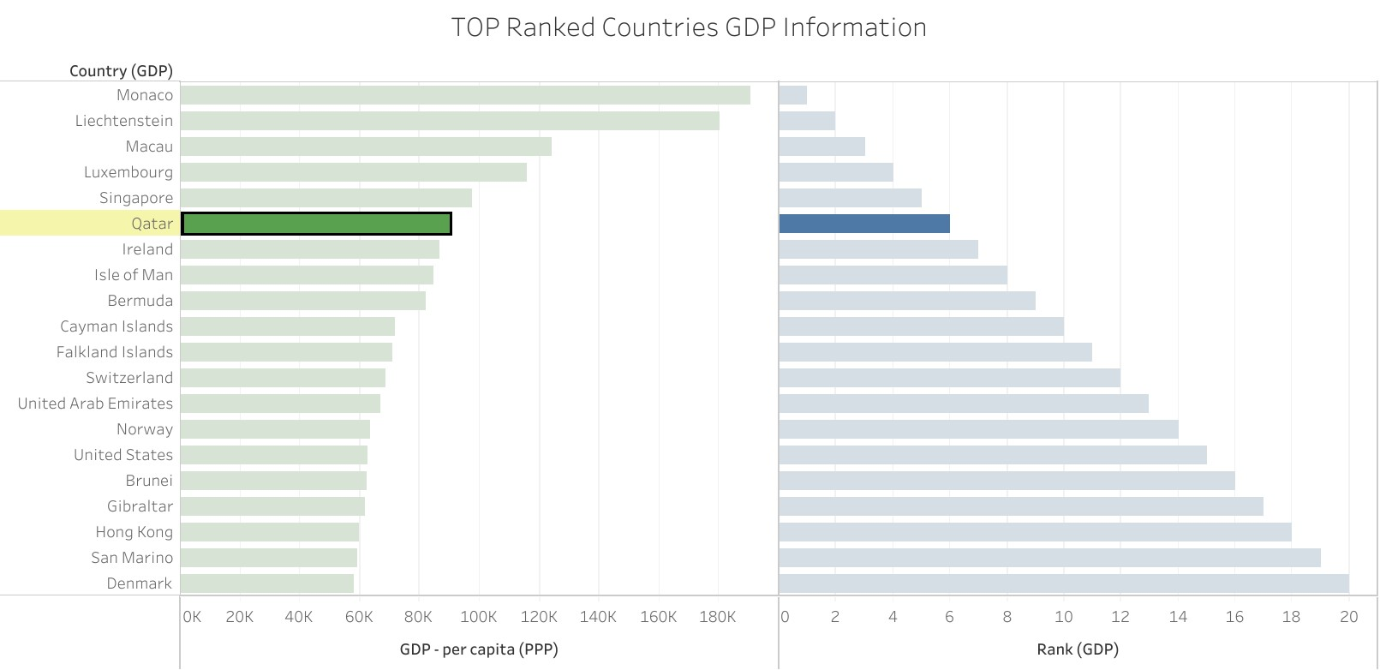

# **6.Top 20 Ranked Countries Life Expectancy at birth Info Chart in Tableau**

Top 20 high ranked countries from Life Expectancy table has been created with calculated Field in order to create the bar chart with following details

* Top 20 High Ranked Countries and its Rank in X axis
* Life Expectancy at birth and Top Ranked Countries in Y axis
* 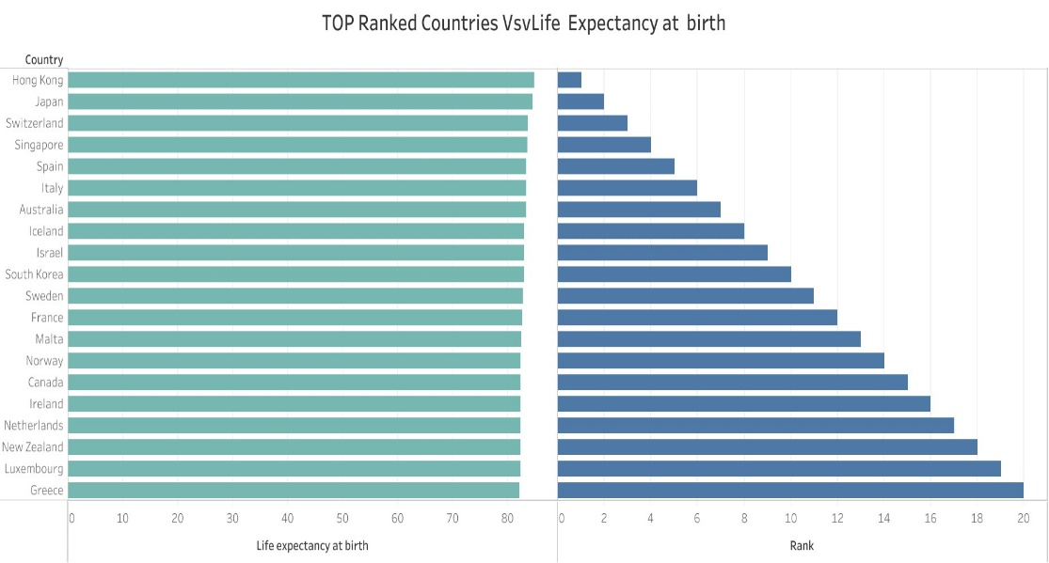

# **7.Top 20 Ranked Countries smartphone users Chart**

Top 20 high ranked countries from Smartphone Users table have been created with calculated Field in order to create the bar chart with following details

* Top 20 High Ranked Countries and its Rank in X axis
* Average of Smartphone users and Top Ranked Countries in Y axis

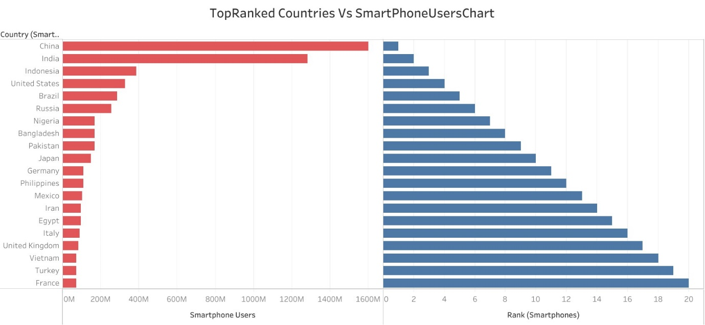

# 8.Top 20 Ranked Countries Life Expectancy and SmartPhone Uers Chart

Top 20 high ranked countries created from the combination of the two tables Smartphone Users and life expectancy has been created with calculated Field from life expectancy table in order to create the bar chart with following details

* Top 20 High Ranked Countries and its Rank in X axis
* Average of Smartphone users and life expectancy at birth and Life expectancy Top ranked Countries in Y axis
* 